**EX NO: 7 Examining Network Address Translation (NAT) using Cisco Packet**

**DATE:27.08.24 Tracer**

# Aim:

To Examine Network Address Translation (NAT) using Cisco Packet Tracer

# Setting Up the Network Topology

* + **Devices Required:**

1. Two PCs (for testing connectivity)
2. Two router (to configure NAT)
3. Two switch (to connect the PCs and the router)
4. One server (to simulate an external network, like the internet)

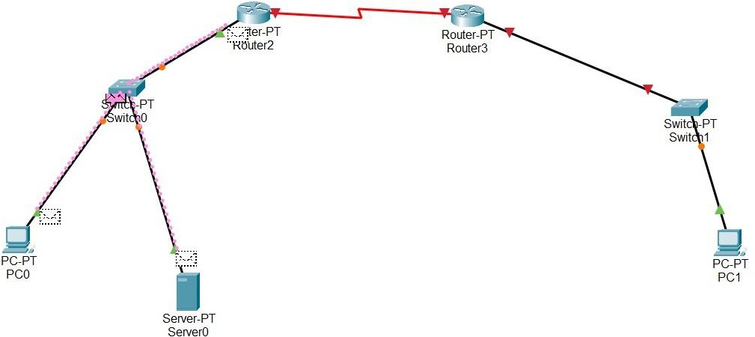

# Steps:

1. **Place the Devices:** Drag and drop the required devices onto the workspace.
2. **Connect the Devices:** Use the appropriate cables (copper straight-through for PCs to the switch, copper cross-over for switch to router) to connect the devices.

# Assign IP Addresses:

* + Assign private IP addresses (10.10.10.0/20) to the PC1 and the router1 Internal interface.
  + Assign a public IP address (50.50.50/30) to the router1 external interface.
  + Assign an IP address to the server that simulates an external network (10.10.10.2).
  + Assign private IP addresses (20.20.20.0/20) to the PC2 and the router2 Internal interface.
  + Assign a public IP address (60.60.60/30) to the router2 external interface.

# 2. Configuring NAT on the Router Steps:

1. **Access the Router CLI:** Click on the router and go to the CLI tab.

# Enter Global Configuration Mode:

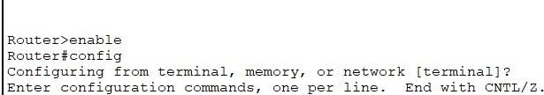

1. **Configure Interfaces:**

Set up the internal and external interfaces:

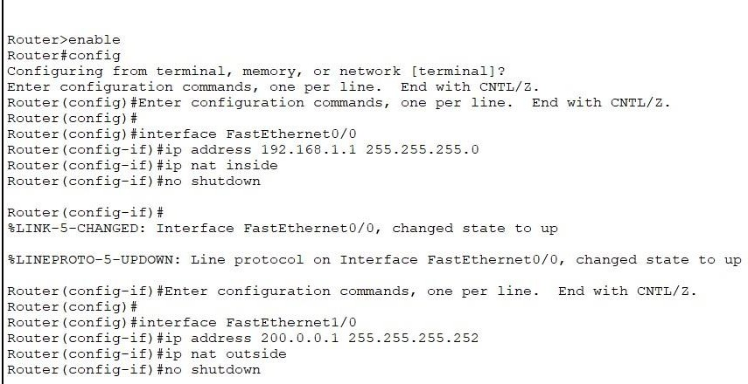

# Configure NAT Overload (PAT):

Define an access list to match the internal IP range:

* + Configure NAT to translate the internal addresses to the external address.
  + This configures PAT (Port Address Translation), which allows multiple internal IPs to share a single external IP.

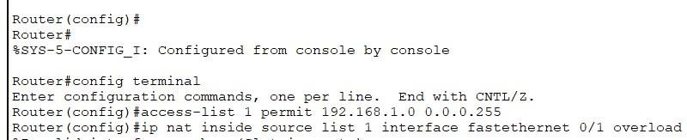

# 3. Testing NAT

**Steps:**

1. Ping from a PC to the External Network:

From one of the PCs, open the command prompt and try to ping the external server (e.g., ping 200.0.0.2).

1. Verify NAT Translations:

On the router CLI, check the NAT translation table to see the active translations:



1. Observe the Output:

The NAT translation table should show the mapping of the internal private IP addresses to the external public IP.

# Observing the Traffic

* + Use the simulation mode in Packet Tracer to visually observe the NAT process as packets move from the internal network to the external network.

# Saving the Configuration

Don't forget to save the configuration on the router to avoid losing the settings:

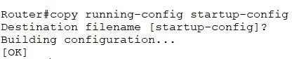

# Result:

Thus,we successfully, we examine network address Translations(NAT) using Cisco Packet Tracer.